
East West University
Department of Computer Science and Engineering

Course: CSE251 Electronic Circuits
Expt No.: 8
Title: Introduction to Transistor

Objectives:

- Identify base, emitter and collector terminals and connections of NPN and PNP transistors.
- Demonstrate and measure the effects on base current of forward and reverse bias in the emitter-base circuit.

Theory:

It is convenient to represent the current voltage characteristics of transistor graphically. In a BJT common-emitter (CE) configuration, the emitter serves as the common terminal between input and output. The input is applied at the base terminal and the output is taken from the collector terminal. The typical CE output describes i_{C} as a function of V_{CE} with i_{B} as a parameter. In the active mode, i_{C} of practical BJTs shows some dependence on V_{CE} due to early effect. As a result, i_{C} characteristics are not horizontal straight lines. This dependency of i_{c} on V_{CE} is included in the equivalent circuit via an output resistance r_{O}.

Equipments and Components Needed:

- Power supply
- Multimeter
- Resistor (100KΩ and 1.8KΩ)
- Transistor (NPN and PNP)
- Voltmeter
- DC milli-ammeter and DC micro-ammeter

PROCEDURE:

- Measure β (h _{FE}) of the transistor with the ammeter and record the value.
- Construct the circuit as shown in the figure 1. Use DC power supply for V_{BB} and 0-15 V variable DC voltage from trainer board for V_{CC}. Connect the micro-ammeter in the base circuit and milli-ammeter in the collector circuit. Make sure to connect the ammeters with the correct polarity.
- Adjust V_{BB} so that I_{B} ia about 5uA. Vary V_{CE} in steps of 1 V form 10 V to 1 V by changing V_{CC}. Keep I_{B} constant during this measurement. V_{CE} may be measured with digital multimeter. Next vary V_{CE} in steps of 0.1 V from 1 V to 0V. Measure I_{C} and V_{CE} in each step.

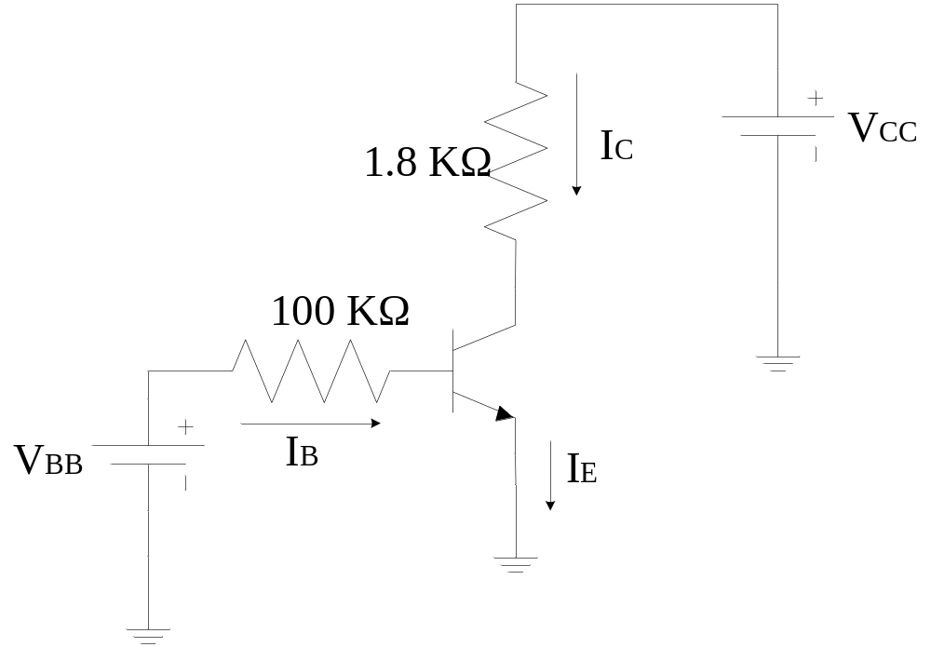

Figure 1 Circuit diagram for measuring I-V characteristics of Transistor

Post-Lab Report Questions:
Plot I_{C}-V_{CE} characteristics curves from the measured data using PSPICE and MATLAB

